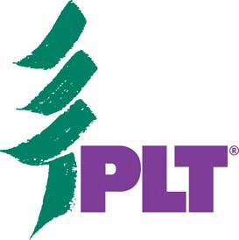
2121 K Street NW, Suite 750
Washington, D.C. 20037

Photo and Video Release Form

Individuals over the age of 18 may sign for themselves; those under 18 must have this release signed by their parent or guardian.

I hereby consent to the use of photographs and/or video of my child/dependent/self in any editorial and/or promotional material produced and/or published by or about Project Learning Tree (PLT), a program of the Sustainable Forestry Initiative Inc. (SFI).

I expressly grant to SFI and PLT and PLT state sponsoring organizations unlimited permissions to use, re-use, publish, and re-publish information about me and reproductions of my likeness (photographic or otherwise), with or without my name, for purposes of advertising, public relations, marketing, trade, or any other lawful use. I waive the opportunity to inspect and/or approve the finished product, promotional copy, or other use that it may be used in connection therewith.

I understand that signing this release does not guarantee publication of a photo and/or video.

MSU Extension: I hereby grant MSU Extension the absolute and irrevocable right and permission, with respect to photographs, audio & video taken of me and/or comments made by me (We will review all comments with you before quoting you.) or in which I may be included with others, to copyright for same; to use, reuse and publish the same in whole or in part in any and all media including use on the internet now or hereafter, and for any purpose whatsoever for illustration, promotion, art, advertising and trade, and if appropriate, to use my name and pertinent education and/or biographical facts as MSU Extension chooses. http://forestry.msuextension.org/mfsp/pdf/MediaRelease.pdf

Name of person photographed (PLEASE PRINT) Age (if minor)

Address

City, State, and Zip Code

Signature Date

Consent of parent or legal guardian if above individual is a minor.

Signature Relationship

